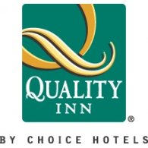
Quality Inn – St. George North
912 West Red Cliffs Drive
Washington, Utah 84780
UCLS – 2021 Convention Rate
$85.00
February 17th & 18th 2021
Please contact John Olsen directly by phone or email for more details.
Office: 435-673-3537 | Mobile: 435-619-3037 Email: john.olsen@greens.com

